Supplementary information

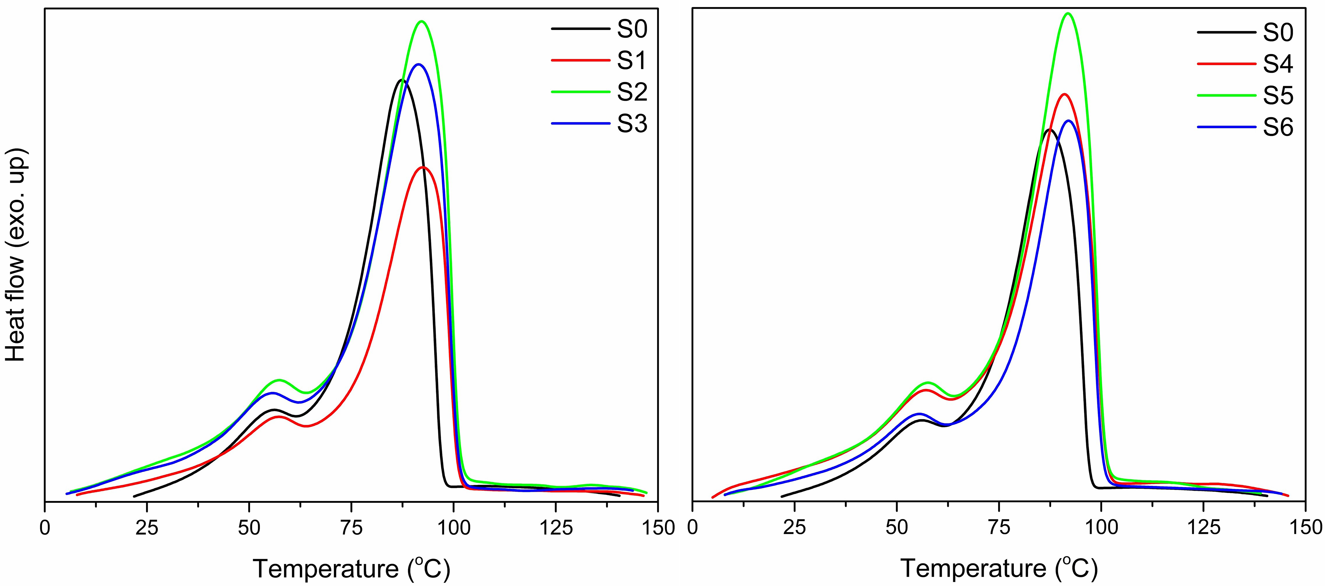
SI.1. Crystalization thermograms of samples recorded during cooling step.

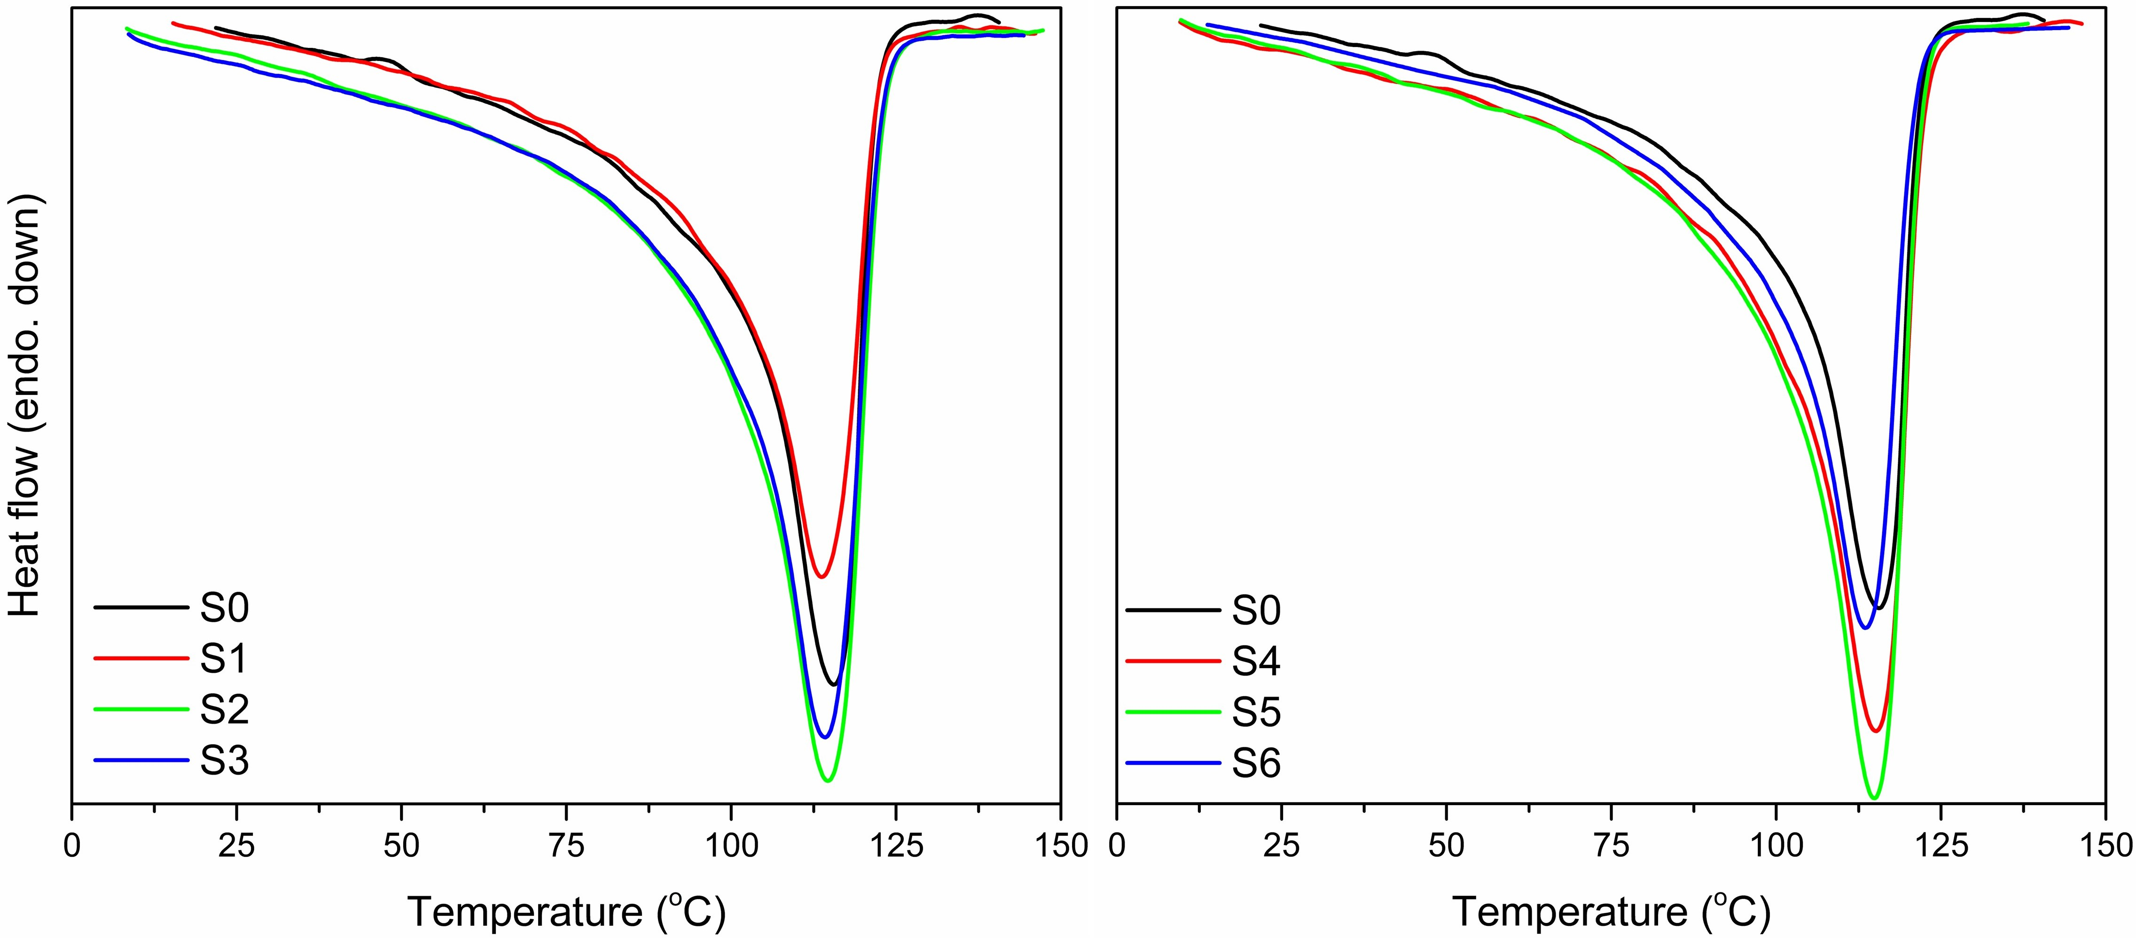
SI.2. Melting thermograms of samples recorded during second heating step.

